# Lab-14-1: Docker Swarm

# Objectives

* Deploying docker containers on Docker Swarm

--------------------------------------------------------------------------------------------------

**Today:**

Login to your ubuntu installation (either locally, through Azure/AWS instance) where you have installed docker before.

Docker Swarm is a system that lets us manage containers across a collection of Docker hosts. It’s already included in more recent versions of Docker, so there is nothing extra to install. In one sense, it’s just an additional set of docker commands to run

**Task 1: Set up your Swarm**

Create a docker swarm

--------------------------------------------------------------------------------

Initialize docker swarm and make the current node as manager

* docker swarm init

Q1. What is the command to run other nodes to this swarm

**Ans: sudo docker swarm join --token SWMTKN-1-#### 10.0.0.155:2377**

**Q2.** What is the command to add managers to the swarm

**Ans**: sudo docker swarm join-token manager

**Q3**. What does the following command show:

Docker node ls

**Ans: lists the nodes in a swarm**

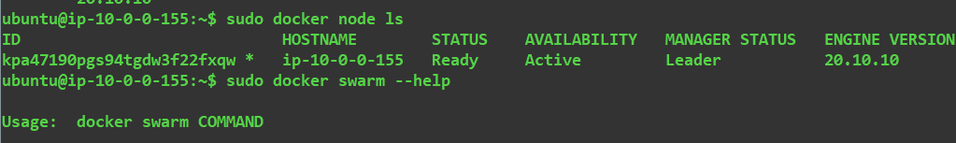

**Task2: Create and manage a docker service**

A swarm service is a set of containers built from the same image that you have directed to be run on your swarm.

Start your first service that runs two containers from the image you build for lab 13-2 with the command

* docker service create – -name hi –replicas 2 user/flaskapp

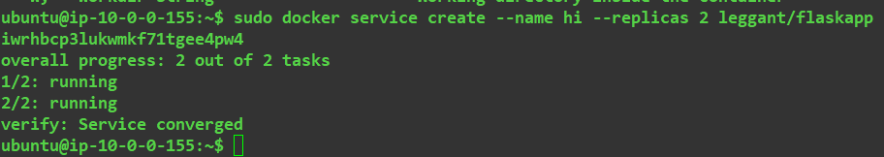

Check the status of your service with the command

* docker service ls

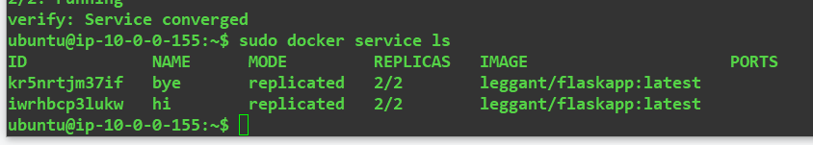

See where your containers running

* docker service ps hi

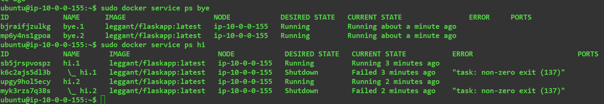

use docker ps to find id of the container and stop it using the following command

* docker stop <container_id>

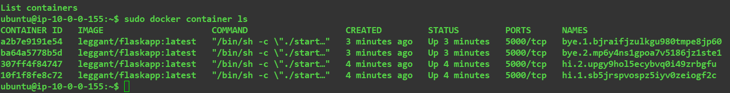

**Q4.** What does the following command show:

Docker service ps hi

**Ans: Shows new containers that have launched automatically to replace the containers that have just been stopped.**

Use the following command to change the number of containers running:

* docker service scale hi=4

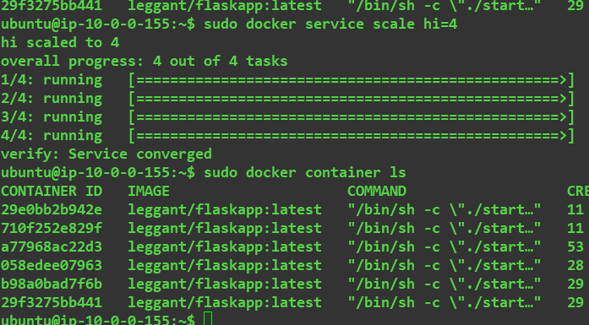

**Q5.** What is the command to check if the containers are running?

**Ans:**

Sudo docker container ls

Stop the service

* docker service rm hi

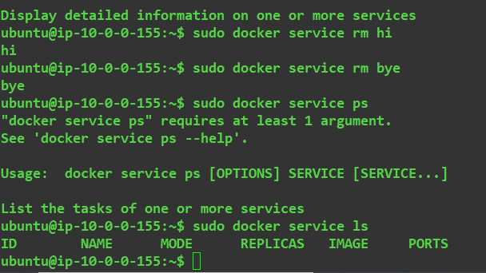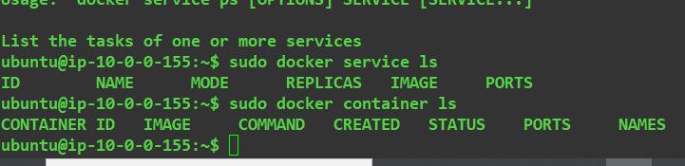

**Submission:** screen shots of running Q4 and Q5 answers

[hints: <https://docs.docker.com/engine/reference/commandline/swarm/>

<https://docs.docker.com/engine/reference/commandline/service> ]

**Task 3: Setup a service with a compose file**

Use the previous (lab 13-2) compose file and adapt it to use on Docker swarm

Docker Swarm compose

- Since you can’t use build in a swarm setting, remove that.

- Any images you need to build must be pushed up to Docker Hub.

- Specify that you will use an overlay network

**Submission:** Swarm compose file